<http://21propertymanagement.com/component/users/?view=login>

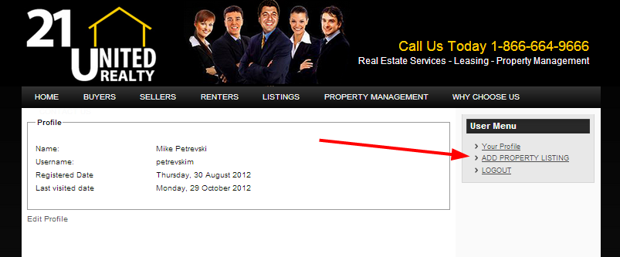

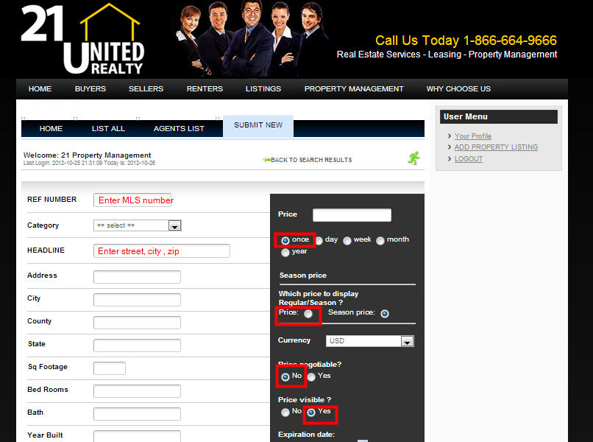

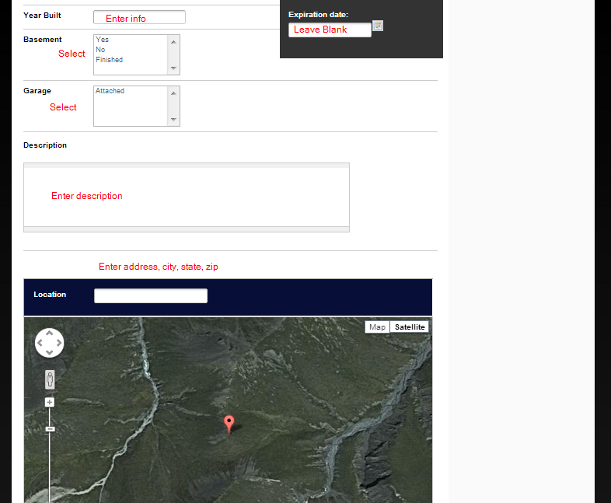

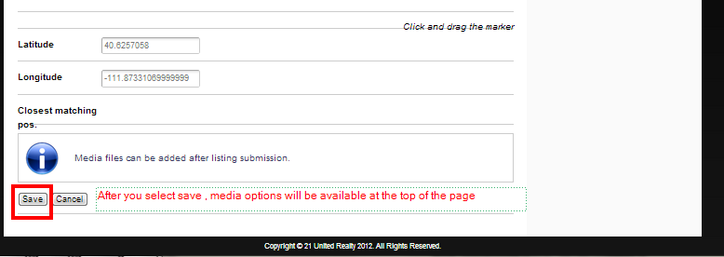

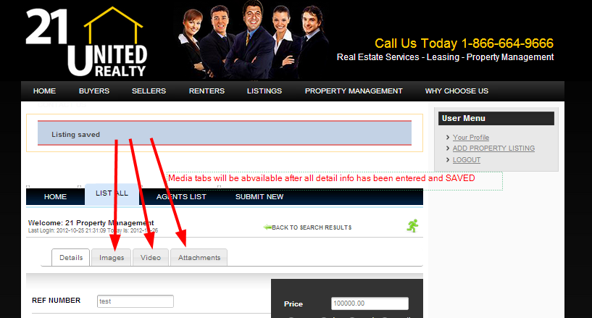

Images tab

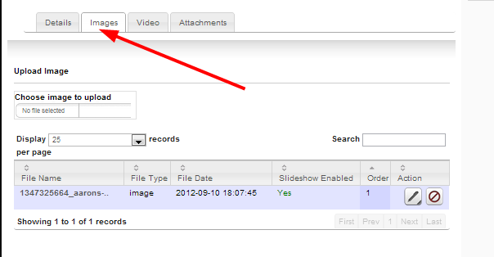

Upload images of the property and select yes for slideshow

Video tab

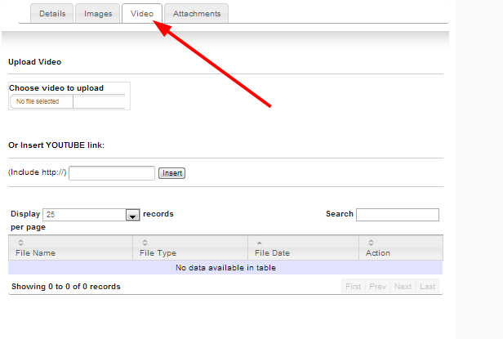

Upload virtual video tours here.

We are working on getting all the virtual tours on youtube and taking advantage of the insert youtube link

above

Attachments tab

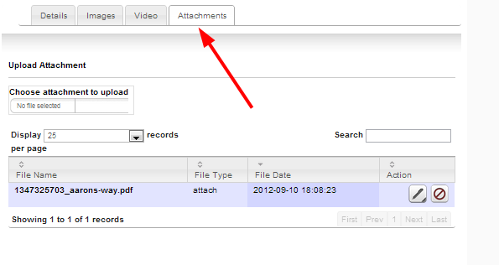

Upload attachments such as the actual property listing

View AARONS WAY, BRANDON TWP 48462 property

This property has the listing pdf attached to it